Experiment No-01
Experiment name: To develop a program and simulate the Pulse Amplitude Modulation (PAM) signal and analyze its waveform.
Objectives:
- To understand the fundamental concept of Pulse Amplitude Modulation (PAM)
- To develop a simulation program for PAM using Python/MATLAB
- To observe how a continuous signal is converted into a pulse-based signal
- To analyze the waveform characteristics of the PAM signal
Theory
Pulse Amplitude Modulation (PAM) is one of the simplest forms of analog modulation in which the amplitude of a series of pulses is varied in accordance with the instantaneous amplitude of the message signal. In this technique, the information signal is first sampled at regular intervals, and each sample controls the height (amplitude) of a corresponding pulse. As a result, the output becomes a sequence of pulses whose amplitudes represent the original signal.
In practical communication systems, PAM plays a crucial role because it acts as a foundation for many digital modulation techniques. It is widely used in signal processing, data communication, and analog-to-digital conversion systems.
Mathematically, the PAM signal can be expressed as:
$$s(t)=\sum_{n=-∞}^{∞}{x(n}T_{s})⋅p(t-nT_{s})$$
Here,
- $x(nT_{s})$represents the sampled values of the original signal,
- $T_{s}$is the sampling interval,
- $p(t)$is the pulse shape (usually rectangular in flat-top PAM).
This equation shows that the PAM signal is formed by multiplying each sample with a pulse and shifting it in time.
According to the Nyquist Sampling Theorem, in order to reconstruct the original signal accurately, the sampling frequency $f_{s}$must satisfy:
$$f_{s}≥2f_{max}$$
where $f_{max}$is the highest frequency present in the message signal. If this condition is not satisfied, distortion known as aliasing occurs.
There are mainly two types of PAM:
- Natural PAM: The pulse follows the shape of the signal during the pulse duration
- Flat-top PAM: The pulse amplitude remains constant during the sampling interval (used in digital systems)
Code:
import numpy as np
import matplotlib.pyplot as plt

# Time axis
t = np.linspace(0, 1, 1000)

# Message signal (sine wave)
fm = 5
message = np.sin(2 * np.pi * fm * t)

# Sampling parameters
fs = 50
ts = np.arange(0, 1 + 1/fs, 1/fs)
samples = np.sin(2 * np.pi * fm * ts)

# Generate PAM signal (flat-top)
pam_signal = np.zeros_like(t)

for i in range(len(ts)):
idx = np.where((t >= ts[i]) & (t < ts[i] + 1/fs))
pam_signal[idx] = samples[i]

# Plot message signal
plt.figure()
plt.plot(t, message)
plt.title("Original Message Signal")
plt.xlabel("Time")
plt.ylabel("Amplitude")
plt.grid()

# Plot PAM signal
plt.figure()
plt.plot(t, pam_signal)
plt.title("PAM Signal (Flat-top)")
plt.xlabel("Time")
plt.ylabel("Amplitude")
plt.grid()

plt.show()
Results:
The PAM signal consists of rectangular pulses . Pulse amplitudes vary according to the message signal . The waveform clearly shows discrete sampling behavior.
Discussion:
The simulation demonstrates how a continuous signal can be converted into a pulse-based representation using PAM. Each pulse carries information about the signal at a specific sampling instant. The results clearly show that the shape of the original signal is preserved in terms of amplitude variation.
It is observed that the sampling frequency plays a critical role in determining the quality of the PAM signal. When the sampling frequency is sufficiently high, the PAM waveform closely follows the original signal. However, if the sampling rate is reduced, distortion may occur due to loss of information.
Output:
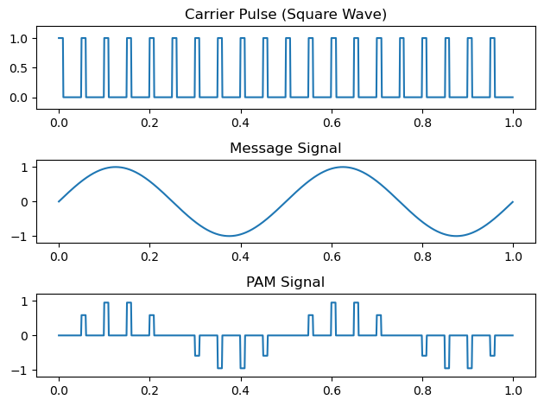

Experiment No-02
Experiment Name: To design a program and simulate the Amplitude Shift Keying (ASK) modulation technique
Objectives:
- To understand the concept of Amplitude Shift Keying (ASK)
- To design and implement ASK modulation using Python
- To observe the ASK waveform and its characteristics
- To analyze how binary data is transmitted using amplitude variation
Theory
Amplitude Shift Keying (ASK) is a digital modulation technique in which the amplitude of a carrier signal is varied according to the binary data, while the frequency and phase remain constant. It is one of the simplest forms of digital modulation and is widely used in communication systems where simplicity is required.
In ASK modulation, the binary data consists of two levels: binary ‘1’ and binary ‘0’. These two values are represented by two different amplitudes of the carrier signal. Typically, a binary ‘1’ is transmitted by sending a carrier signal with full amplitude, while a binary ‘0’ is represented by either no signal or a signal with zero amplitude. This type of ASK is also known as On-Off Keying (OOK).
Mathematically, the ASK signal can be expressed as:
$$s(t)=\left\{\begin{matrix}Acos⁡(2πf_{c}t), & \text{for binary 1} \\ 0, & \text{for binary 0}\end{matrix}\right.$$
Where:
- $A$= amplitude of the carrier signal
- $f_{c}$= carrier frequency
- $t$= time
This equation shows that the presence or absence of the carrier signal depends on the input binary data.
The binary data sequence is first converted into a digital waveform, which is then used to control the amplitude of the carrier signal. When the input bit is ‘1’, the carrier is transmitted; when it is ‘0’, the carrier is suppressed. This results in a modulated waveform where the amplitude changes according to the digital input.
Code:
import numpy as np
import matplotlib.pyplot as plt

# Data
x = np.array([1,0,1,0,1,0,1,0,1])
bp = 1e-6

# Digital signal
bit = np.repeat(x, 100)
t1 = np.arange(0, bp*len(x), bp/100)

# ASK Modulation
A1, A2 = 10, 5
f = 10/bp
t2 = np.linspace(0, bp, 100)

m = np.concatenate([
(A1 if b==1 else A2)*np.cos(2*np.pi*f*t2) for b in x
])

t3 = np.linspace(0, bp*len(x), len(m))

# Demodulation
mn = []
for i in range(len(x)):
seg = m[i*100:(i+1)*100]
z = np.trapz(seg*np.cos(2*np.pi*f*t2), t2)
mn.append(1 if (2*z/bp)>7.5 else 0)

mn = np.array(mn)

# Received signal
bit_rec = np.repeat(mn, 100)
t4 = np.arange(0, bp*len(mn), bp/100)

# Plots
plt.subplot(3,1,1); plt.plot(t1,bit); plt.title("Input Signal")
plt.subplot(3,1,2); plt.plot(t3,m); plt.title("ASK Signal")
plt.subplot(3,1,3); plt.plot(t4,bit_rec); plt.title("Output Signal")
plt.tight_layout(); plt.show()

print("Tx:", x)
print("Rx:", mn)

Output:
Tx: [1 0 1 0 1 0 1 0 1]
Rx: [1 0 1 0 1 0 1 0 1]
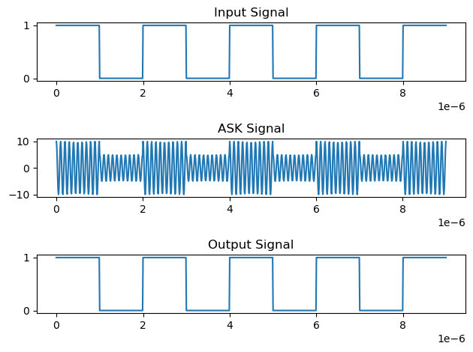
Results:
- The ASK signal shows carrier presence for ‘1’ and absence for ‘0’
- The waveform clearly represents binary data through amplitude variation
- The modulation process is successfully demonstrated
Discussion:
The experiment shows how binary data can be transmitted using amplitude variation of a carrier signal. The ASK waveform clearly reflects the input bit sequence, where the carrier is present during ‘1’ and absent during ‘0’.

Experiment No-03
Experiment name: To construct a program and simulate the Phase Shift Keying (PSK) modulation technique.

Objectives:
- To understand the concept of Phase Shift Keying (PSK)
- To design and simulate PSK modulation using Python/MATLAB
- To observe how binary data is transmitted using phase variation
- To analyze the PSK waveform characteristics

Theory:
Phase Shift Keying (PSK) is a digital modulation technique in which the phase of a carrier signal is varied according to the input binary data, while the amplitude and frequency remain constant. It is widely used in modern communication systems due to its high noise immunity and efficient bandwidth utilization.
In the simplest form, known as Binary Phase Shift Keying (BPSK), two different phases are used to represent binary data. Typically, a phase of 0° represents binary ‘1’, and a phase of 180° represents binary ‘0’. This means that the carrier signal is either transmitted as it is or inverted depending on the input bit.
Mathematically, the PSK signal can be expressed as:
$$s(t)=Acos⁡(2πf_{c}t+θ)$$
Where:
- $A$= amplitude of the carrier signal
- $f_{c}$= carrier frequency
- $θ$= phase shift (0 or $π$)
For BPSK specifically:
$$s(t)=\left\{\begin{matrix}Acos⁡(2πf_{c}t), & \text{for binary 1} \\ Acos⁡(2πf_{c}t+π), & \text{for binary 0}\end{matrix}\right.$$
Since:
$$cos⁡(ωt+π)=-cos⁡(ωt)$$
The equation simplifies to:
$$s(t)=±Acos⁡(2πf_{c}t)$$
This shows that PSK modulation can be implemented by simply changing the sign (phase) of the carrier signal based on the input bit.
PSK is more robust than ASK because noise mainly affects amplitude, not phase, making PSK more reliable in practical communication systems.

Code:
import numpy as np
import matplotlib.pyplot as plt

# Data
x = np.array([1,0,1,0,1,0,1,0,1])
bp = 1e-6

print("Tx:", x)

# Digital signal
bit = np.repeat(x, 100)
t1 = np.arange(0, bp*len(x), bp/100)

# PSK Modulation
A = 5
f = 2 / bp
t2 = np.linspace(0, bp, 100)

m = np.concatenate([
A*np.cos(2*np.pi*f*t2) if b==1 else A*np.cos(2*np.pi*f*t2 + np.pi)
for b in x
])

t3 = np.linspace(0, bp*len(x), len(m))

# Demodulation
mn = []
for i in range(len(x)):
seg = m[i*100:(i+1)*100]
z = np.trapz(seg*np.cos(2*np.pi*f*t2), t2)
mn.append(1 if (2*z/bp)>0 else 0)

mn = np.array(mn)
print("Rx:", mn)

# Received signal
bit_rec = np.repeat(mn, 100)
t4 = np.arange(0, bp*len(mn), bp/100)

# Plot
plt.subplot(3,1,1); plt.plot(t1,bit); plt.title("Input Signal")
plt.subplot(3,1,2); plt.plot(t3,m); plt.title("PSK Signal")
plt.subplot(3,1,3); plt.plot(t4,bit_rec); plt.title("Output Signal")

plt.tight_layout()
plt.show()

Output:
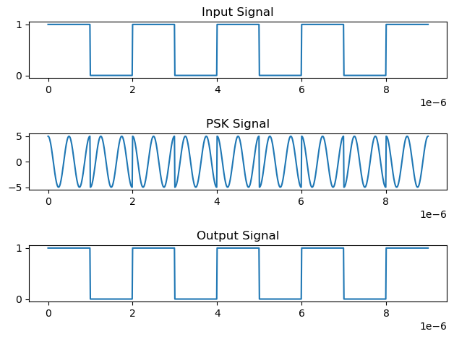
Results:
- The PSK signal shows phase inversion for binary ‘0’
- The amplitude remains constant throughout
- Phase changes occur at bit transitions

Discussion:
The simulation demonstrates how binary data is transmitted using phase variations of a carrier signal. Unlike ASK, the amplitude remains constant, which makes PSK more resistant to noise.

Experiment No-04
Experiment Name: To create a program and simulate the Frequency Shift Keying (FSK) modulation technique

Objectives:
- To understand the concept of Frequency Shift Keying (FSK)
- To design and simulate FSK modulation using Python/MATLAB
- To observe how binary data is transmitted using frequency variation
- To analyze the FSK waveform characteristics

Theory:
Frequency Shift Keying (FSK) is a digital modulation technique in which the frequency of a carrier signal is varied according to the input binary data, while its amplitude and phase remain constant. It is widely used in digital communication systems due to its robustness against noise and interference.
In FSK, binary data is represented using two different frequencies. Typically, a higher frequency $f_{1}$is used to represent binary ‘1’, and a lower frequency $f_{0}$is used to represent binary ‘0’. This type of modulation is specifically called Binary Frequency Shift Keying (BFSK).
The mathematical representation of an FSK signal is given by:
$$s(t)=\left\{\begin{matrix}Acos⁡(2πf_{1}t), & \text{for binary 1} \\ Acos⁡(2πf_{0}t), & \text{for binary 0}\end{matrix}\right.$$
Where:
- $A$= amplitude of the carrier signal
- $f_{1}$= frequency representing binary ‘1’
- $f_{0}$= frequency representing binary ‘0’
This equation shows that the transmitted signal switches between two different frequencies depending on the input binary sequence.
The binary input signal is first converted into a digital waveform. Based on this waveform, the system selects one of the two carrier frequencies. As a result, the output signal continuously changes its frequency according to the input bits.
FSK has better noise immunity compared to ASK because noise primarily affects amplitude rather than frequency. However, it requires more bandwidth than ASK and PSK due to the use of multiple frequencies.
FSK is widely used in practical applications such as:
- Radio communication systems
- Data transmission over telephone lines
- Bluetooth and wireless communication
- Modems and telemetry systems

Code:

import numpy as np
import matplotlib.pyplot as plt

# Data
x = np.array([1,1,0,1,0,1])
bp = 1e-6

print("Tx:", x)

# Digital signal
bit = np.repeat(x, 100)
t1 = np.arange(0, bp*len(x), bp/100)

# FSK Modulation
A = 5
f1 = 8 / bp # for bit 1
f2 = 2 / bp # for bit 0
t2 = np.linspace(0, bp, 100)

m = np.concatenate([
A*np.cos(2*np.pi*f1*t2) if b==1 else A*np.cos(2*np.pi*f2*t2)
for b in x
])

t3 = np.linspace(0, bp*len(x), len(m))

# Demodulation
mn = []
for i in range(len(x)):
seg = m[i*100:(i+1)*100]

z1 = np.trapz(seg*np.cos(2*np.pi*f1*t2), t2)
z2 = np.trapz(seg*np.cos(2*np.pi*f2*t2), t2)

mn.append(1 if z1 > z2 else 0)

mn = np.array(mn)
print("Rx:", mn)

# Output signal
bit_rec = np.repeat(mn, 100)
t4 = np.arange(0, bp*len(mn), bp/100)

# Plot
plt.subplot(3,1,1); plt.plot(t1, bit); plt.title("Input")
plt.subplot(3,1,2); plt.plot(t3, m); plt.title("FSK")
plt.subplot(3,1,3); plt.plot(t4, bit_rec); plt.title("Output")

plt.tight_layout()
plt.show()

Output:
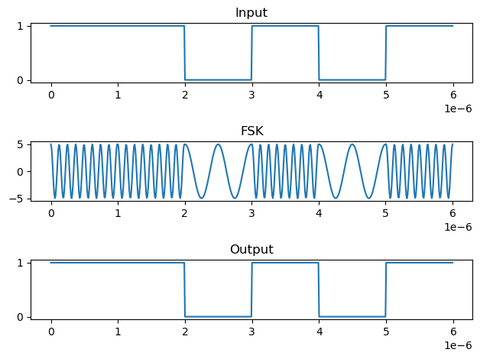
Results:
- The FSK signal shows frequency changes based on binary input
- High frequency represents ‘1’ and low frequency represents ‘0’
- Amplitude remains constant

Discussion:
The simulation demonstrates how binary data can be transmitted using different frequencies of a carrier signal. Unlike ASK and PSK, FSK uses frequency variation, making it more resistant to noise.

Experiment No-05
Experiment name: To implement a program and simulate the Unipolar Non-Return-to-Zero (NRZ) signaling technique.

Objectives:
- To understand the concept of Unipolar NRZ signaling
- To design and simulate NRZ encoding using Python/MATLAB
- To observe the waveform representation of binary data
- To analyze the characteristics of NRZ signaling

Theory
Unipolar Non-Return-to-Zero (NRZ) is a line coding technique used in digital communication to represent binary data in the form of electrical signals. In this method, only one polarity (positive voltage) is used to represent the binary information, which is why it is called unipolar.
In Unipolar NRZ signaling, the signal does not return to zero between consecutive bits. Instead, the voltage level remains constant throughout the bit duration. Typically, a binary ‘1’ is represented by a positive voltage level, while a binary ‘0’ is represented by zero voltage.
Mathematically, the Unipolar NRZ signal can be expressed as:
$$s(t)=\left\{\begin{matrix}A, & \text{for binary 1} \\ 0, & \text{for binary 0}\end{matrix}\right.$$
Where:
- $A$= amplitude of the signal
- $t$= time
This means that whenever the input bit is ‘1’, the signal stays at a constant positive level for the entire bit duration. For ‘0’, the signal remains at zero.
The term Non-Return-to-Zero (NRZ) indicates that the signal does not return to zero between bits, unlike Return-to-Zero (RZ) signaling where the signal drops back to zero within each bit period.
Unipolar NRZ is simple and easy to implement, but it has some limitations. One major issue is the presence of a DC component, which can cause problems in transmission systems. Additionally, long sequences of zeros or ones can lead to synchronization problems, since there are no transitions to help the receiver identify bit boundaries.
Despite these drawbacks, NRZ signaling forms the basis for many other line coding techniques used in digital communication systems.

Code:
import numpy as np
import matplotlib.pyplot as plt

# Number of bits
N = 10

# Random bits (0 or 1)
n = np.random.randint(0, 2, N)
print("Bits:", n)

# Time axis
t = np.arange(0, N, 0.01)

# Signal shaping (repeat each bit)
y = np.repeat(n, int(len(t)/N))

# Plot
plt.plot(t, y, linewidth=2)
plt.axis([0, N, -1.5, 1.5])
plt.grid()
plt.title("Unipolar NRZ Signaling")
plt.xlabel("Time")
plt.ylabel("Amplitude")

plt.show()

Output:
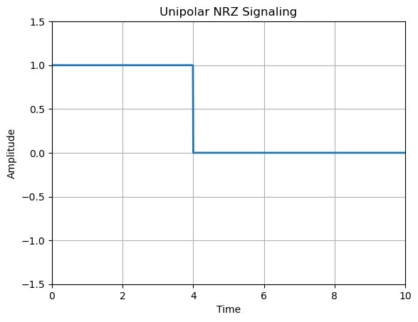
Results:
- Binary ‘1’ is represented by a constant positive level
- Binary ‘0’ is represented by zero level
- The signal does not return to zero between bits

Discussion:
The simulation demonstrates how binary data is represented using Unipolar NRZ signaling. The waveform clearly shows constant voltage levels corresponding to the input bits, without returning to zero between bit intervals.

Experiment No: 06
Experiment Name: To model a program and simulate the Polar Non-Return-to-Zero (NRZ) signaling technique.

Objectives
- To understand the concept of Polar NRZ signaling
- To design and simulate Polar NRZ encoding using Python/MATLAB
- To observe waveform representation of binary data
- To analyze characteristics and advantages over unipolar signaling

Theory
Polar Non-Return-to-Zero (NRZ) is a widely used line coding technique in digital communication systems, where binary data is represented using two opposite voltage levels. Unlike unipolar signaling, which uses only positive voltage, polar signaling uses both positive and negative amplitudes, making it more efficient and balanced.
In Polar NRZ signaling, the signal does not return to zero between bits. Instead, it maintains a constant level throughout the entire bit duration. Typically:
- Binary ‘1’ is represented by a positive voltage (+A)
- Binary ‘0’ is represented by a negative voltage (−A)
This method is often referred to as NRZ-Level (NRZ-L) because the signal level directly represents the bit value.
Mathematically, the Polar NRZ signal can be expressed as:
$$s(t)=\left\{\begin{matrix}+A, & \text{for binary 1} \\ -A, & \text{for binary 0}\end{matrix}\right.$$
Where:
- $A$= amplitude of the signal
- $t$= time
This representation ensures that the signal has no DC component (on average), which makes it more suitable for transmission over communication channels compared to unipolar NRZ.
Since the signal does not return to zero between bits, bandwidth efficiency is improved. However, similar to unipolar NRZ, long sequences of identical bits (all 1s or all 0s) can still cause synchronization issues, as there are no transitions to help the receiver detect bit boundaries.
Polar NRZ is widely used in digital systems and forms the basis for more advanced encoding techniques such as Manchester coding and differential encoding.

Code:
import numpy as np
import matplotlib.pyplot as plt

# Number of bits
N = 10

# Random bits
n = np.random.randint(0, 2, N)
print("Bits:", n)

# Mapping: 1 → +1, 0 → -1
nn = np.where(n == 1, 1, -1)

# Time axis
t = np.arange(0, N, 0.01)

# Signal shaping (repeat each bit)
y = np.repeat(nn, int(len(t)/N))

# Plot
plt.plot(t, y, linewidth=2)
plt.axis([0, N, -1.5, 1.5])
plt.grid()
plt.title("Polar NRZ Signaling")
plt.xlabel("Time")
plt.ylabel("Amplitude")

plt.show()

Output:
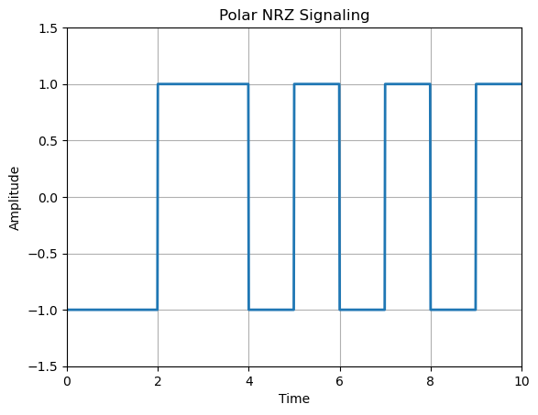
Results:
- Binary ‘1’ is represented by positive amplitude (+A)
- Binary ‘0’ is represented by negative amplitude (−A)
- Signal does not return to zero between bits
Discussion:
The simulation shows how binary data is represented using two opposite voltage levels. Compared to unipolar NRZ, Polar NRZ provides better signal balance and reduces DC components, improving transmission quality.
Experiment No-07
Experiment Name: To write a program and simulate the Unipolar Return-to-Zero (RZ) signaling technique.

Objectives
- To understand the concept of Unipolar Return-to-Zero (RZ) signaling
- To design and simulate RZ encoding using Python/MATLAB
- To observe waveform representation of binary data
- To analyze characteristics of RZ signaling

Theory
Unipolar Return-to-Zero (RZ) is a line coding technique used in digital communication systems where binary data is represented using only one polarity (positive voltage), and the signal returns to zero within each bit duration.
In this technique, a binary ‘1’ is represented by a positive voltage for half of the bit duration, followed by a return to zero for the remaining half. A binary ‘0’ is represented by zero voltage throughout the entire bit period. This distinguishes RZ from NRZ signaling, where the signal does not return to zero between bits.
Mathematically, the Unipolar RZ signal can be expressed as:
$$s(t)=\left\{\begin{matrix}A, & \text{for }0≤t<\frac{T_{b}}{2}\text{ and bit = 1} \\ 0, & \text{otherwise}\end{matrix}\right.$$
Where:
- $A$= amplitude of the signal
- $T_{b}$= bit duration
- $t$= time within the bit interval
This means that each bit interval is divided into two halves:
- First half → signal carries information
- Second half → signal returns to zero
The return-to-zero property ensures that there is at least one transition in each bit period, which helps in maintaining synchronization between transmitter and receiver.
However, this advantage comes at a cost. Since the signal returns to zero within every bit period, it requires more bandwidth than NRZ signaling. Additionally, it still contains a DC component, which may affect transmission over certain channels.
Unipolar RZ is mainly used in systems where synchronization is important, and it forms the basis for more advanced encoding techniques.

Code:

import numpy as np
import matplotlib.pyplot as plt

# Number of bits
N = 10

# Random bits
n = np.random.randint(0, 2, N)
print("Bits:", n)

# Time axis
t = np.arange(0, N, 0.01)

# Initialize signal
y = np.zeros_like(t)

# RZ shaping (half bit = signal, half = 0)
samples_per_bit = int(len(t)/N)

for i in range(N):
start = i * samples_per_bit
mid = start + samples_per_bit//2

if n[i] == 1:
y[start:mid] = 1 # first half = 1
# second half remains 0

# Plot
plt.plot(t, y, linewidth=2)
plt.axis([0, N, -1.5, 1.5])
plt.grid()
plt.title("Unipolar RZ Signaling")
plt.xlabel("Time")
plt.ylabel("Amplitude")

plt.show()

Output:
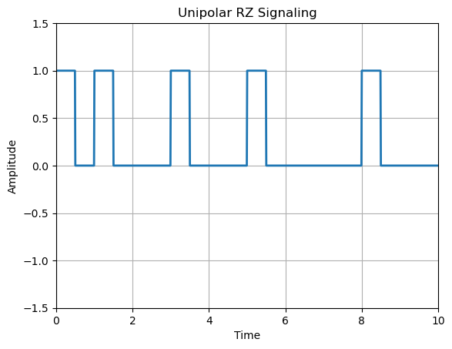
Experiment No-08
Experiment Name: To simulate a program for the Bipolar Return-to-Zero (RZ) signaling technique.

Objectives:
- To understand the concept of Bipolar Return-to-Zero (RZ) signaling
- To design and simulate Bipolar RZ encoding using Python/MATLAB
- To observe waveform representation of binary data
- To analyze the characteristics and advantages of bipolar signaling

Theory
Bipolar Return-to-Zero (RZ) is a line coding technique used in digital communication systems where binary data is represented using both positive and negative voltage levels, and the signal returns to zero within each bit duration. This method combines the advantages of bipolar signaling and return-to-zero encoding, making it more efficient and reliable compared to unipolar schemes.
In Bipolar RZ signaling, a binary ‘1’ is represented by alternating positive and negative pulses (i.e., +A and −A), while a binary ‘0’ is represented by zero voltage. Additionally, for each ‘1’, the signal returns to zero during the second half of the bit duration. This alternating pattern of positive and negative pulses is often referred to as Alternate Mark Inversion (AMI).
Mathematically, the Bipolar RZ signal can be expressed as:
$$s(t)=\left\{\begin{matrix}+A, & \text{for first half of bit when bit = 1 (odd occurrence)} \\ -A, & \text{for first half of bit when bit = 1 (even occurrence)} \\ 0, & \text{for remaining half or when bit = 0}\end{matrix}\right.$$
Where:
- $A$= amplitude of the signal
- $T_{b}$= bit duration
- $t$= time within the bit interval
This means:
- Each ‘1’ alternates between positive and negative pulses
- Each pulse occupies only half of the bit duration
- The signal returns to zero in every bit interval
One major advantage of Bipolar RZ is that it eliminates the DC component, since positive and negative pulses cancel each other over time. This makes it highly suitable for long-distance communication systems.
Additionally, the presence of frequent transitions improves synchronization, allowing the receiver to accurately detect bit boundaries. However, similar to other RZ schemes, it requires higher bandwidth due to the return-to-zero characteristic.
Bipolar RZ is commonly used in telecommunication systems and forms the basis for more advanced encoding techniques.

Code:
import numpy as np
import matplotlib.pyplot as plt

# Number of bits
N = 10

# Random bits
n = np.random.randint(0, 2, N)
print("Bits:", n)

# Bipolar mapping (alternate +1, -1 for 1s)
nn = np.zeros(N)
flag = 1

for i in range(N):
if n[i] == 1:
nn[i] = flag
flag *= -1 # alternate
else:
nn[i] = 0

# Time axis
t = np.arange(0, N, 0.01)

# Signal initialization
y = np.zeros_like(t)

# RZ shaping
samples_per_bit = int(len(t)/N)

for i in range(N):
start = i * samples_per_bit
mid = start + samples_per_bit//2

y[start:mid] = nn[i] # first half
# second half remains 0

# Plot
plt.plot(t, y, linewidth=2)
plt.axis([0, N, -1.5, 1.5])
plt.grid()
plt.title("Bipolar RZ Signaling")
plt.xlabel("Time")
plt.ylabel("Amplitude")

plt.show()

Output:
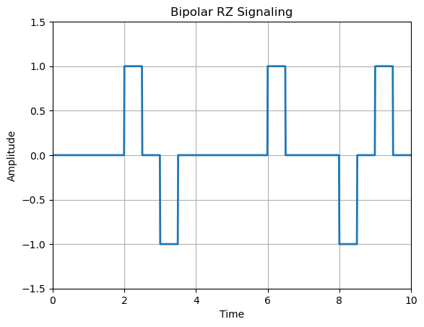
Results:
- Binary ‘1’ is represented by alternating +A and −A pulses
- Signal returns to zero within each bit duration
- Binary ‘0’ remains at zero
Discussion:
The simulation demonstrates how Bipolar RZ signaling represents binary data using alternating positive and negative pulses. This approach provides better signal balance and eliminates DC components.

Experiment No-09
Experiment Name: . To develop a program and simulate the Manchester (Split-Phase) coding technique.
Objectives
- To understand the concept of Manchester (Split-Phase) coding
- To design and simulate Manchester encoding using Python
- To observe waveform representation of binary data
- To analyze its synchronization and transmission properties

Theory
Manchester coding, also known as Split-Phase Encoding, is a widely used line coding technique in digital communication systems where each bit is represented by a transition within the bit duration. Unlike NRZ or RZ signaling, Manchester encoding combines both data and clock information into a single signal, making it highly reliable for synchronization.
In Manchester coding, each bit period is divided into two equal halves. The binary data is represented by a transition at the middle of the bit period:
- Binary ‘1’ → transition from low to high (0 → +A)
- Binary ‘0’ → transition from high to low (+A → 0 or +A → −A depending on convention)
In many standard definitions (IEEE convention):
- ‘1’ = Low → High transition
- ‘0’ = High → Low transition
Mathematically, the Manchester encoded signal can be described as:
$$s(t)=\left\{\begin{matrix}+A, & \text{for }\frac{T_{b}}{2}≤t<T_{b}\text{ (for bit 1)} \\ -A, & \text{for }0≤t<\frac{T_{b}}{2}\text{ (for bit 1)} \\ -A, & \text{for }\frac{T_{b}}{2}≤t<T_{b}\text{ (for bit 0)} \\ +A, & \text{for }0≤t<\frac{T_{b}}{2}\text{ (for bit 0)}\end{matrix}\right.$$
Where:
- $A$= amplitude
- $T_{b}$= bit duration
- $t$= time
This representation ensures that there is always at least one transition per bit, which provides a built-in clocking mechanism.
One of the major advantages of Manchester coding is that it eliminates DC components, making it suitable for transmission over channels that cannot carry DC signals. It also provides excellent synchronization, since the receiver can easily detect bit boundaries from transitions.
However, Manchester coding requires twice the bandwidth compared to NRZ encoding because each bit contains a transition, effectively doubling the signal changes.
Manchester coding is widely used in practical systems such as:
- Ethernet (IEEE 802.3)
- RFID systems
- Data communication protocols

Code:
import numpy as np
import matplotlib.pyplot as plt

# Number of bits
N = 10

# Random bits
n = np.random.randint(0, 2, N)
print("Bits:", n)

# Manchester mapping
# 1 → [1, -1], 0 → [-1, 1]
mapped = np.array([])
for b in n:
mapped = np.append(mapped, [1, -1] if b == 1 else [-1, 1])

# Time axis
t = np.arange(0, N, 0.01)

# Signal shaping (2 levels per bit)
samples_per_bit = int(len(t)/N)
y = np.repeat(mapped, samples_per_bit//2)

# Plot
plt.plot(t, y, linewidth=2)
plt.axis([0, N, -1.5, 1.5])
plt.grid()
plt.title("Manchester Coding")
plt.xlabel("Time")
plt.ylabel("Amplitude")
plt.show()

Output:
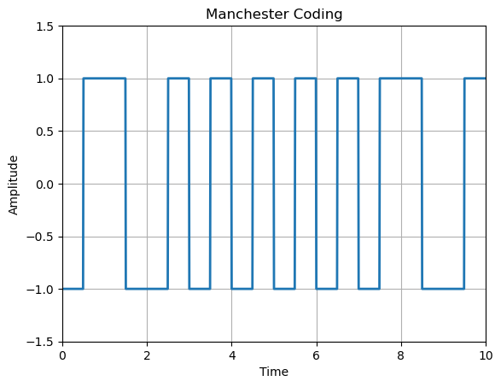
Results:
- Each bit contains a transition at the center
- ‘1’ → Low to High transition
- ‘0’ → High to Low transition
- Signal alternates frequently
Discussion:
The simulation demonstrates how Manchester coding represents binary data using transitions within each bit period. This ensures strong synchronization and eliminates DC components.

Experiment No-10
Experiment Name: Perform the QPSK modulation and demodulation using MATLAB/ Python. Display the signal and its constellation.
Objectives:
- To understand the concept of Quadrature Phase Shift Keying (QPSK).
- To implement QPSK modulation using Python/MATLAB.
- To perform demodulation and recover the original bit stream.
- To visualize:
  - Modulated waveform
  - Constellation diagram
- To evaluate system performance.

Theory:
Quadrature Phase Shift Keying (QPSK) is a digital modulation technique where two bits are transmitted per symbol by varying the phase of a carrier signal.
Key Concept
- Each symbol represents 2 bits:
  - 00 → 45°
  - 01 → 135°
  - 11 → 225°
  - 10 → 315°
- The QPSK signal is given by:
$$s(t)=I(t)cos⁡(2πf_{c}t)+Q(t)sin⁡(2πf_{c}t)$$
Where:
- $I(t)$= In-phase component
- $Q(t)$= Quadrature component
Advantages
- Efficient bandwidth usage
- Higher data rate than BPSK
- Robust against noise
Constellation Diagram
- Represents symbols as points in the I-Q plane
- Four distinct points → 4 phases

Code:
import numpy as np
import matplotlib.pyplot as plt

# Generate random bits
num_bits = 100
bits = np.random.randint(0, 2, num_bits)

# Group bits into pairs
bit_pairs = bits.reshape((-1, 2))

# Mapping (Gray coding)
mapping = {
(0, 0): (1, 1),
(0, 1): (-1, 1),
(1, 1): (-1, -1),
(1, 0): (1, -1)
}

# Modulation
I = []
Q = []

for pair in bit_pairs:
i, q = mapping[tuple(pair)]
I.append(i)
Q.append(q)

I = np.array(I)
Q = np.array(Q)

# Time axis
t = np.linspace(0, 1, len(I))

# Carrier signals
fc = 5
carrier_I = np.cos(2 * np.pi * fc * t)
carrier_Q = np.sin(2 * np.pi * fc * t)

# QPSK Signal
signal = I * carrier_I + Q * carrier_Q

# Plot modulated signal
plt.figure()
plt.plot(t, signal)
plt.title("QPSK Modulated Signal")
plt.xlabel("Time")
plt.ylabel("Amplitude")
plt.grid()

# Constellation diagram
plt.figure()
plt.scatter(I, Q)
plt.title("QPSK Constellation Diagram")
plt.xlabel("In-phase (I)")
plt.ylabel("Quadrature (Q)")
plt.grid()

# Demodulation
received_bits = []

for i, q in zip(I, Q):
if i > 0 and q > 0:
received_bits.extend([0, 0])
elif i < 0 and q > 0:
received_bits.extend([0, 1])
elif i < 0 and q < 0:
received_bits.extend([1, 1])
else:
received_bits.extend([1, 0])

received_bits = np.array(received_bits)

# Accuracy
accuracy = np.sum(bits == received_bits) / len(bits)
print("Accuracy:", accuracy)

plt.show()
Output:
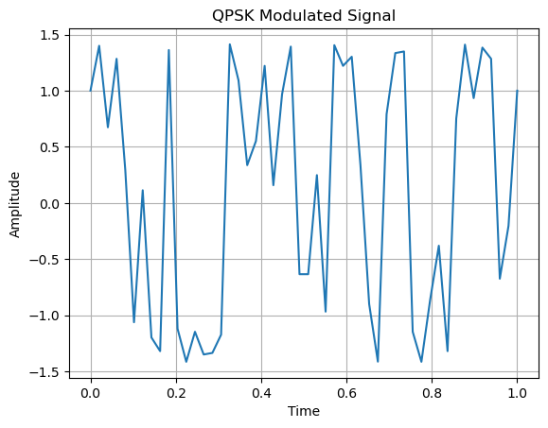
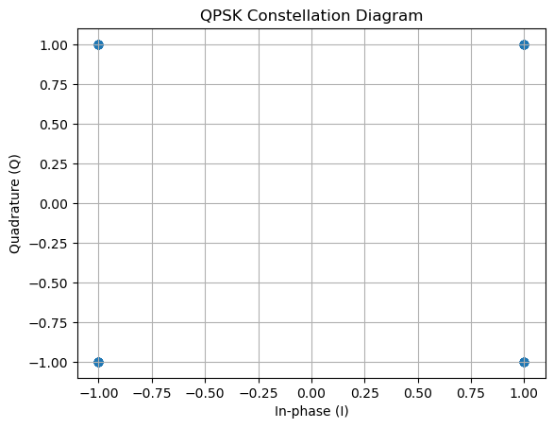

Results:
- The modulated waveform shows phase variations corresponding to input bits.
- The constellation diagram displays four distinct points in the I-Q plane.
- Demodulated bits match transmitted bits with accuracy ≈ 100% (no noise).

Experiment No-11
Experiment Name: Generate 16-QAM modulation and obtain the QAM constellation using Python

Objectives
- To understand the concept of 16-QAM (Quadrature Amplitude Modulation)
- To generate 16-QAM modulated symbols using Python
- To visualize the constellation diagram
- To analyze symbol mapping and signal representation

Theory
Quadrature Amplitude Modulation (QAM) combines both amplitude and phase modulation.
16-QAM Concept
- Each symbol represents 4 bits
- Total symbols = $2^{4}=16$
- Symbols are arranged in a grid (I-Q plane)
Typical amplitude levels:
$$I,Q∈\{-3,-1,+1,+3\}$$
Signal Representation
$$s(t)=I(t)cos⁡(2πf_{c}t)+Q(t)sin⁡(2πf_{c}t)$$
- $I(t)$: In-phase component
- $Q(t)$: Quadrature component
Constellation Diagram
- 16 points arranged in a square grid
- Each point corresponds to a unique 4-bit combination
Advantages
- High data rate (4 bits per symbol)
- Efficient bandwidth utilization
Disadvantages
- More sensitive to noise than QPSK
- Requires higher SNR

Code:

import numpy as np
import matplotlib.pyplot as plt

# Number of bits
num_bits = 400

# Generate random bits
bits = np.random.randint(0, 2, num_bits)

# Group bits into 4 (since 16-QAM)
bit_groups = bits.reshape((-1, 4))

# Mapping (Gray coding)
mapping_table = {
(0,0,0,0): (-3, -3),
(0,0,0,1): (-3, -1),
(0,0,1,1): (-3, +1),
(0,0,1,0): (-3, +3),

(0,1,0,0): (-1, -3),
(0,1,0,1): (-1, -1),
(0,1,1,1): (-1, +1),
(0,1,1,0): (-1, +3),

(1,1,0,0): (+1, -3),
(1,1,0,1): (+1, -1),
(1,1,1,1): (+1, +1),
(1,1,1,0): (+1, +3),

(1,0,0,0): (+3, -3),
(1,0,0,1): (+3, -1),
(1,0,1,1): (+3, +1),
(1,0,1,0): (+3, +3)
}

# Map bits to symbols
I = []
Q = []

for group in bit_groups:
i, q = mapping_table[tuple(group)]
I.append(i)
Q.append(q)

I = np.array(I)
Q = np.array(Q)

# Constellation plot
plt.figure()
plt.scatter(I, Q)

# Labeling points (optional)
for i, q in zip(I[:16], Q[:16]):
plt.text(i, q, f'({i},{q})')

plt.title("16-QAM Constellation Diagram")
plt.xlabel("In-phase (I)")
plt.ylabel("Quadrature (Q)")
plt.grid()

plt.show()

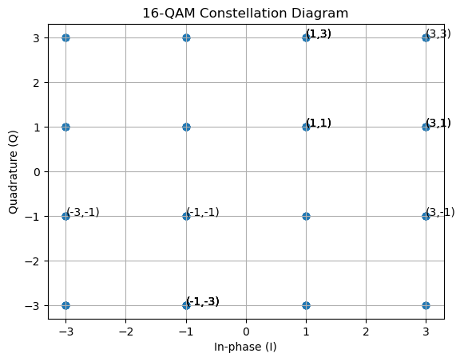
Output:

Results:
- The constellation consists of 16 distinct points
- Points are arranged in a 4×4 grid
- Each point represents a unique 4-bit symbol

Experiment No-12
Experiment Name: Perform sampling and reconstruction of continuous signal using Python

Objectives
- To understand the concept of signal sampling
- To verify the Nyquist Sampling Theorem
- To perform signal reconstruction from sampled data
- To visualize:
  - Original continuous signal
  - Sampled signal
  - Reconstructed signa

Theory

Sampling
Sampling is the process of converting a continuous-time signal into a discrete-time signal by taking values at specific intervals.
If a signal is $x(t)$, the sampled version is:
$$x[n]=x(nT_{s})$$
Where:
- $T_{s}$= Sampling period
- $f_{s}=\frac{1}{T_{s}}$= Sampling frequency

Nyquist Theorem
According to the Nyquist Sampling Theorem:
$$f_{s}≥2f_{max}$$
- $f_{max}$= Maximum frequency of the signal
- If this condition is not met → aliasing occurs

Reconstruction
Reconstruction is the process of recovering the original signal from sampled data.
Ideal reconstruction uses sinc interpolation:
$$x(t)=\sum_{n=-∞}^{∞}{x[n]⋅\text{sinc}}\left(\frac{t-nT_{s}}{T_{s}}\right)$$

Code:
import numpy as np
import matplotlib.pyplot as plt
from scipy.interpolate import interp1d

# Continuous signal
t = np.linspace(0, 1, 1000)
f = 5
x = np.sin(2 * np.pi * f * t)

# Sampling
fs = 20
ts = np.arange(0, 1 + 1/fs, 1/fs)
xs = np.sin(2 * np.pi * f * ts)

# Reconstruction (FIXED)
interp_func = interp1d(ts, xs, kind='cubic', fill_value="extrapolate")
xr = interp_func(t)

# Plot
plt.plot(t, x, label="Original")
plt.plot(t, xr, '--', label="Reconstructed")
plt.scatter(ts, xs, color='red', label="Samples")
plt.legend()
plt.grid()
plt.show()

Output:
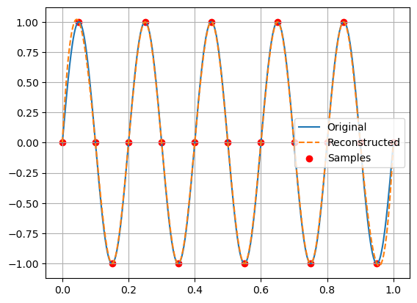

Experiment No-13
Experiment Name: To generate the waveform of Quadrature Phase Shift Keying signal using Python.
Objectives:
- To understand the working principle of QPSK modulation
- To generate QPSK waveform using Python/MATLAB
- To visualize:
- In-phase (I) signal
- Quadrature (Q) signal
- Final QPSK modulated waveform
- To analyze phase changes corresponding to input bits

Theory
Quadrature Phase Shift Keying (QPSK) is a digital modulation technique where two bits are transmitted per symbol using four different phase shifts.
Bit Mapping
Each pair of bits corresponds to a phase:
Bits | Phase
00 | 45°
01 | 135°
11 | 225°
10 | 315°

Signal Representation
$$s(t)=I(t)cos⁡(2πf_{c}t)+Q(t)sin⁡(2πf_{c}t)$$
Where:
- $I(t)$= In-phase component
- $Q(t)$= Quadrature component
- $f_{c}$= Carrier frequency

Working Principle
- Input bits → grouped into pairs
- Each pair → mapped to I and Q values
- Two carriers:
  - Cosine → I channel
  - Sine → Q channel
- Combined → QPSK waveform

Code:
import numpy as np
import matplotlib.pyplot as plt

# Generate random bits
num_bits = 20
bits = np.random.randint(0, 2, num_bits)

# Ensure even number of bits
if len(bits) % 2 != 0:
bits = np.append(bits, 0)

# Group bits into pairs
bit_pairs = bits.reshape((-1, 2))

# Mapping (Gray coding)
mapping = {
(0, 0): (1, 1),
(0, 1): (-1, 1),
(1, 1): (-1, -1),
(1, 0): (1, -1)
}

I = []
Q = []

for pair in bit_pairs:
i, q = mapping[tuple(pair)]
I.append(i)
Q.append(q)

I = np.array(I)
Q = np.array(Q)

# Time parameters
Tb = 1 # bit duration
fc = 5 # carrier frequency
t = np.linspace(0, Tb * len(I), 1000)

# Expand I and Q to match time axis
I_signal = np.repeat(I, len(t)//len(I))
Q_signal = np.repeat(Q, len(t)//len(Q))

# Carrier signals
carrier_I = np.cos(2 * np.pi * fc * t)
carrier_Q = np.sin(2 * np.pi * fc * t)

# QPSK Signal
qpsk_signal = I_signal * carrier_I + Q_signal * carrier_Q

# Plot I signal
plt.figure()
plt.step(range(len(I)), I, where='mid')
plt.title("In-phase (I) Signal")
plt.xlabel("Symbol Index")
plt.ylabel("Amplitude")
plt.grid()

# Plot Q signal
plt.figure()
plt.step(range(len(Q)), Q, where='mid')
plt.title("Quadrature (Q) Signal")
plt.xlabel("Symbol Index")
plt.ylabel("Amplitude")
plt.grid()

# Plot QPSK waveform
plt.figure()
plt.plot(t, qpsk_signal)
plt.title("QPSK Modulated Waveform")
plt.xlabel("Time")
plt.ylabel("Amplitude")
plt.grid()
plt.show()
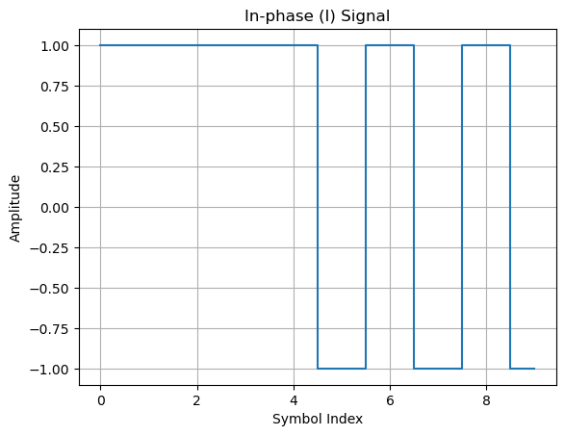
Output:

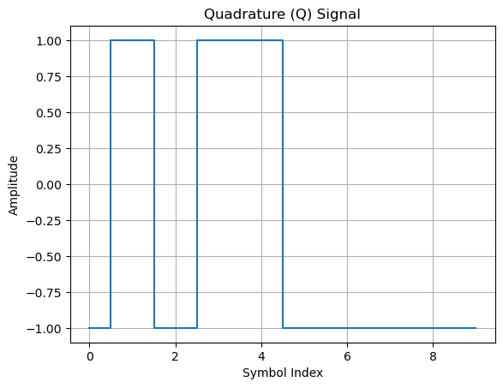
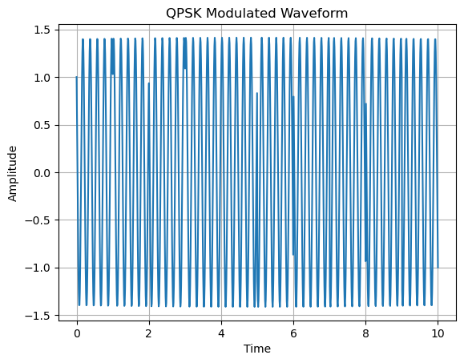



Results:
- The waveform shows phase changes corresponding to bit pairs
- Each symbol interval has a distinct phase
- I and Q components correctly combine to form QPSK signal

Experiment No-14
Experiment Name: Perform the PAM modulation and demodulation using Python.

Objectives
- To understand the concept of Pulse Amplitude Modulation (PAM)
- To implement PAM modulation using Python/MATLAB
- To perform demodulation and recover the original signal
- To visualize:
- Original message signal
- PAM modulated signal
- Reconstructed signal
Theory:
Pulse Amplitude Modulation (PAM)
PAM is a modulation technique where the amplitude of pulses is varied according to the message signal.

Types of PAM
- Natural PAM
- Flat-top PAM (used in digital systems)

PAM Signal Representation
$$s(t)=\sum_{n=-∞}^{∞}{x(n}T_{s})⋅p(t-nT_{s})$$
Where:
- $x(nT_{s})$= Sampled signal
- $p(t)$= Pulse shape
- $T_{s}$= Sampling interval

Demodulation
- Extract samples from PAM signal
- Use low-pass filter or interpolation to reconstruct original signal

Advantages
- Simple implementation
- Basis for other modulation schemes
Disadvantages
- Sensitive to noise
- Requires synchronization

Code:
import numpy as np
import matplotlib.pyplot as plt
from scipy.interpolate import interp1d

# Time axis for continuous signal
t = np.linspace(0, 1, 1000)

# Message signal (sine wave)
fm = 5
message = np.sin(2 * np.pi * fm * t)

# Sampling parameters
fs = 50
ts = np.arange(0, 1 + 1/fs, 1/fs)
samples = np.sin(2 * np.pi * fm * ts)

# Generate PAM signal (flat-top)
pam_signal = np.zeros_like(t)

for i in range(len(ts)):
idx = np.where((t >= ts[i]) & (t < ts[i] + 1/fs))
pam_signal[idx] = samples[i]

# Demodulation (reconstruction using interpolation)
interp_func = interp1d(ts, samples, kind='cubic', fill_value="extrapolate")
reconstructed = interp_func(t)

# Plot message signal
plt.figure()
plt.plot(t, message)
plt.title("Original Message Signal")
plt.xlabel("Time")
plt.ylabel("Amplitude")
plt.grid()

# Plot PAM signal
plt.figure()
plt.plot(t, pam_signal)
plt.title("PAM Modulated Signal")
plt.xlabel("Time")
plt.ylabel("Amplitude")
plt.grid()

# Plot reconstructed signal
plt.figure()
plt.plot(t, message, label="Original")
plt.plot(t, reconstructed, '--', label="Reconstructed")
plt.title("Demodulated Signal")
plt.xlabel("Time")
plt.ylabel("Amplitude")
plt.legend()
plt.grid()

plt.show()

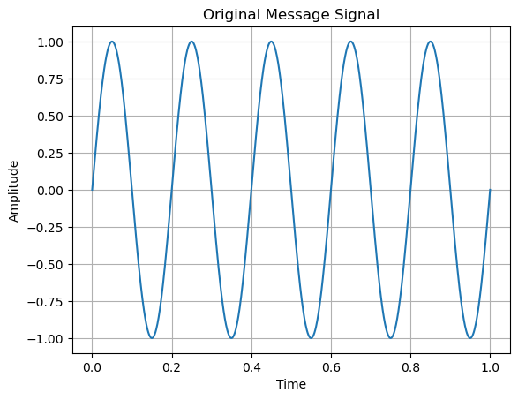
Output:

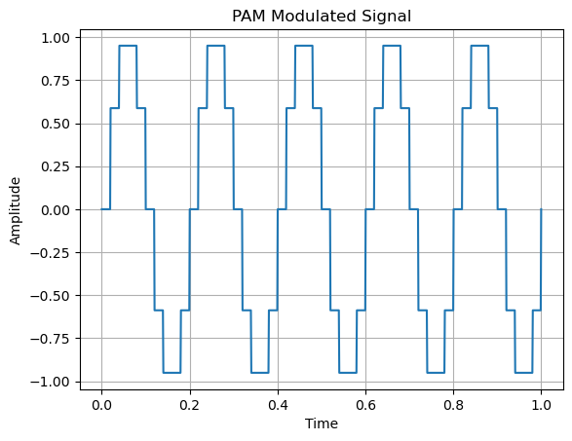

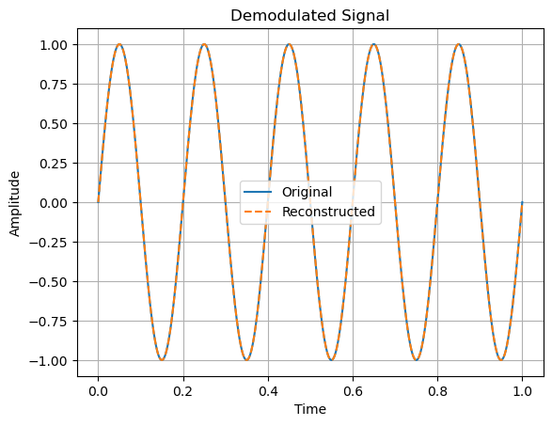

Experiment No-15
Experiment Name:Perform the DPCM modulation and demodulation using MATLAB/ Python.

Objectives:
- To understand the concept of Differential Pulse Code Modulation (DPCM)
- To implement DPCM encoding (modulation) using Python
- To perform DPCM decoding (demodulation)
- To compare original and reconstructed signals

Theory:
DPCM-
Differential Pulse Code Modulation (DPCM) is a signal encoding technique where we encode the difference between consecutive samples instead of absolute values.

Basic Idea
Instead of transmitting $x[n]$, we transmit:
$$d[n]=x[n]-\hat{x}[n]$$
Where:
- $x[n]$= actual signal
- $\hat{x}[n]$= predicted signal
- $d[n]$= difference (error signal)
Encoder (Modulation)
- Predict next sample
- Compute difference
- Quantize the difference
- Transmit encoded value
Decoder (Demodulation)
- Receive quantized difference
- Add to predicted value
- Reconstruct signal

Advantages
- Reduces redundancy
- Requires fewer bits than PCM
- Efficient for correlated signals
Disadvantages
- Error propagation
- Complexity in prediction

Code:
import numpy as np
import matplotlib.pyplot as plt

# Generate input signal
t = np.linspace(0, 1, 500)
x = np.sin(2 * np.pi * 5 * t)

# DPCM Encoding
predicted = np.zeros_like(x)
error = np.zeros_like(x)

for i in range(1, len(x)):
predicted[i] = x[i-1] # simple predictor
error[i] = x[i] - predicted[i]

# Quantization (simple rounding)
quantized_error = np.round(error, 2)

# DPCM Decoding
reconstructed = np.zeros_like(x)

for i in range(1, len(x)):
reconstructed[i] = reconstructed[i-1] + quantized_error[i]

# Plot original signal
plt.figure()
plt.plot(t, x)
plt.title("Original Signal")
plt.xlabel("Time")
plt.ylabel("Amplitude")
plt.grid()

# Plot error signal
plt.figure()
plt.plot(t, error)
plt.title("DPCM Error Signal")
plt.xlabel("Time")
plt.ylabel("Amplitude")
plt.grid()

# Plot reconstructed signal
plt.figure()
plt.plot(t, x, label="Original")
plt.plot(t, reconstructed, '--', label="Reconstructed")
plt.title("Reconstructed Signal (DPCM)")
plt.xlabel("Time")
plt.ylabel("Amplitude")
plt.legend()
plt.grid()

plt.show()

Output:
